**Adding an AWS Environment**

**Overview**

There are three main steps to adding your WorkSpaces environment to Goliath and one optional.

1. Create an IAM Policy
2. Optionally limit which AWS objects are included for monitoring.
3. Create an IAM Role
4. Add Environment to Goliath

**Create an AWS IAM Policy**

1. Within the AWS console, go to the IAM area and click **Policies.  
   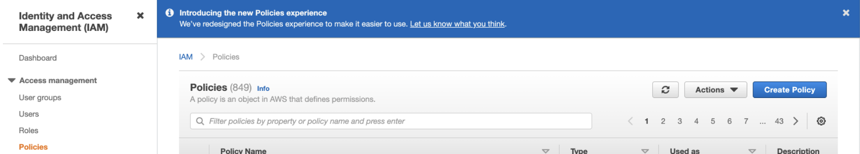**
2. Click **Create Policy**.
3. Note that the following policy will add both WorkSpaces and EC2. If you need to limit access, refer to the next section below. In the Create Policy dialog, click the **JSON** tab and paste the following:

{  
  
    "Version": "2012-10-17",  
    "Statement": [  
        {  
            "Sid": "VisualEditor0",  
            "Effect": "Allow",  
            "Action": [  
                "ec2:DescribeInstances",  
 "ec2:DescribeRegions",  
                "cloudwatch:GetMetricStatistics",  
 "cloudwatch:ListMetrics",  
                "workspaces:DescribeWorkspaces"  
            ],  
            "Resource": "*"  
        }  
    ]  
}

1. Click **Next**.
2. At the tags step, click **Next**
3. Give the policy a name, for example "GoliathWorkSpaces"
4. Click **Create Policy**.  
   The Policy is added to the list of Policies displayed.

**Limiting AWS Resources (Optional)**

If you would like to only include specific resources for monitoring, you have multiple options.

**To include Workspaces** **only**, modify the Action section of the policy described above to:

               "ec2:DescribeRegions",  
                "cloudwatch:GetMetricStatistics",  
                "cloudwatch:ListMetrics",  
                "workspaces:DescribeWorkspaces"

**To include EC2 only**, modify the Action section of the policy described above to:

               "ec2:DescribeInstances",  
                "ec2:DescribeRegions",  
                "cloudwatch:GetMetricStatistics",  
                "cloudwatch:ListMetrics"

**Create an AWS IAM Role**

1. Click **Roles** (in the left-hand menu).
2. Click **Create Role.  
   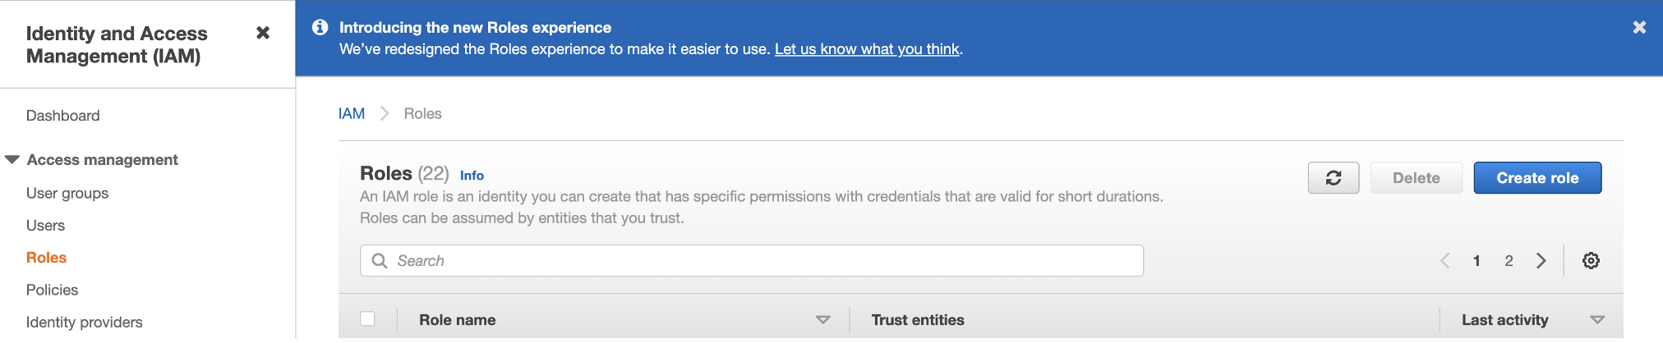**
3. Selected the trusted entity type: **Another AWS Account  
   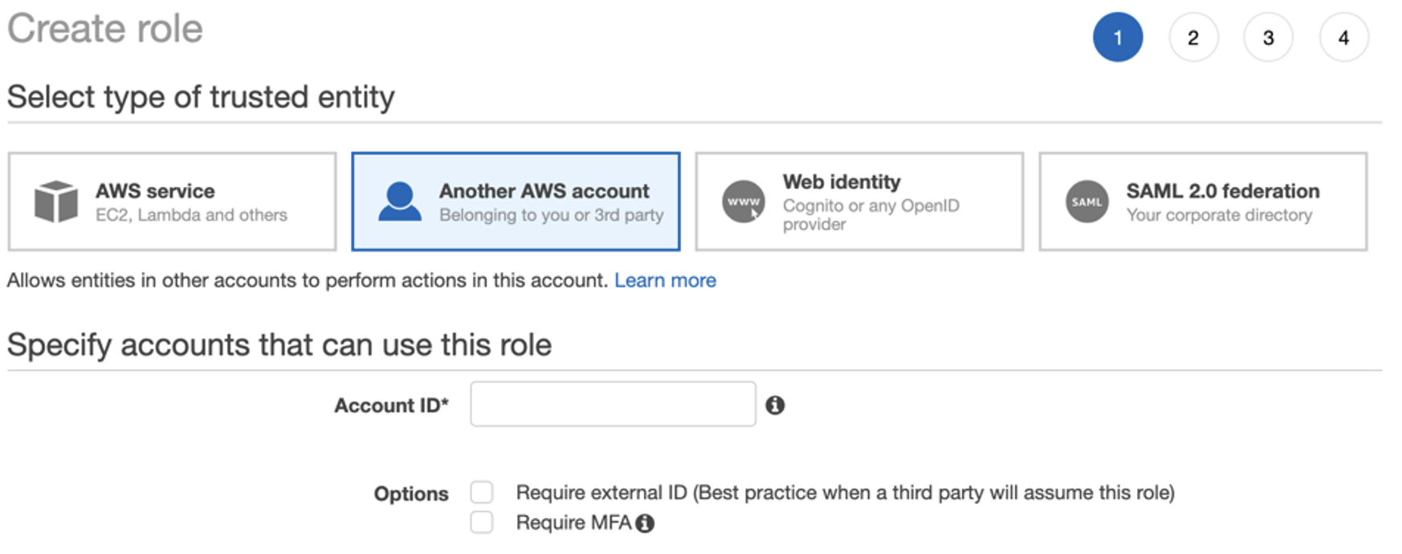**
4. Enter Goliath's account ID: 101893991639
5. Click **Next**.
6. At the Policy step, select the checkbox next to the policy you created earlier. (Use the search bar to filter the list).
7. Click
8. At the tags step, click **Next**
9. Give the role a name, for example "Goliath"
10. Click **Create**.  
      
    Next, from the list of roles, click the name of the new role you created. At the top of the page, you will see the **Role ARN** - you're going to need this next when adding the WorkSpaces environment to the Goliath interface.

**Add the AWS Environment to the Goliath interface**

1. Go to [goliathapp.com](http://www.goliathapp.com)
2. Sign in with the credentials you were provided.
3. In the **Add Environment** dialog that opens, enter a display name, for example "My AWS"  
   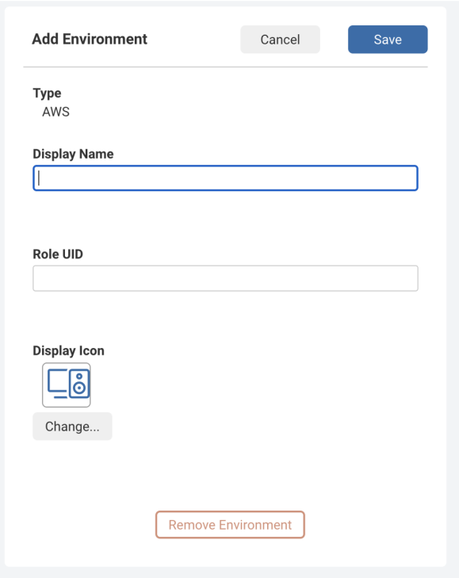
4. In the **Role ARN** input field, paste the **Role ARN** from the role created earlier within AWS. You can find the Role ARN right at the top of the page when you click in to view the Role details.
5. Optionally change the **Display Icon.**
6. Click **Save.**

The AWS environment is added to the main menu on the left beneath an AWS parent menu object. Data will begin to populate the dashboards within a few minutes.

You can customize what is displayed on each dashboard by clicking the menu in the top right and selecting **Customize** **Widgets**.